Bode Plots for Higher Order Systems Build Bode plot for G(s) = $\frac{5(s+1)(s-50)}{s^{2}(s^{2}+10s+100)}$
Point by point Technique
Factor constants, integrators, 1st and 2nd order systems: G(s) =
Complete the following table for G(s). For terms whose magnitude and phase slopes change, list the non-zero slope in the Magnitude and Phase columns. For terms whose slope does not change, list the constant value in the Magnitude and Phase columns. Include units for your answers in the Magnitude and Phase columns.
Term | Break Freq | Type | Magnitude | Phase
 | N/A | Constant
 | “0” rad/sec | Integrator
 | 1 rad/sec | 1 LHP Z
 | 10 rad/sec | 2 LHP P
 | 50 rad/sec | 1 RHP Z

Determine points on Magnitude portion of Bode Plot
- Find the lowest non-zero break frequency: ____ rad/sec
Determine the magnitude of constants and integrators at this frequency
Constant: $20\log\left(\left|{ ___ }/{ ___ }\right|\right)= dB$
Integrator: $20\log\left(\left|1/{{(jω)}^{2}}\right|\right)|_{ω= _____ rad/sec}=0$
Determine the slope to left of this frequency: __________dB/decade

- Find the next larger break frequency: ____ rad/sec
Determine the slope at this frequency: ____dB/decade from 1/s^2
____dB/decade from s+1/1 total: ____dB/decade
Determine magnitude at this frequency: #decades: log(___ rad/sec/___ rad sec) = ___ decade
#dB: ____dB/decade * ___ decade = ____dB
Mag: ____________ = ______

- Find the next larger break frequency: ___ rad/sec
Determine the slope at this frequency: ___dB/decade from 1/s^2
___dB/decade from s+1/1
___dB/decade from second order total: ___dB/decade
Determine magnitude at this frequency: #decades: log(___ rad/sec/___ rad sec) = ___ decade
#dB: ____dB/decade * ___ decade = ____dB
Mag: ____________ = ______
- Determine slope to right last break frequency:
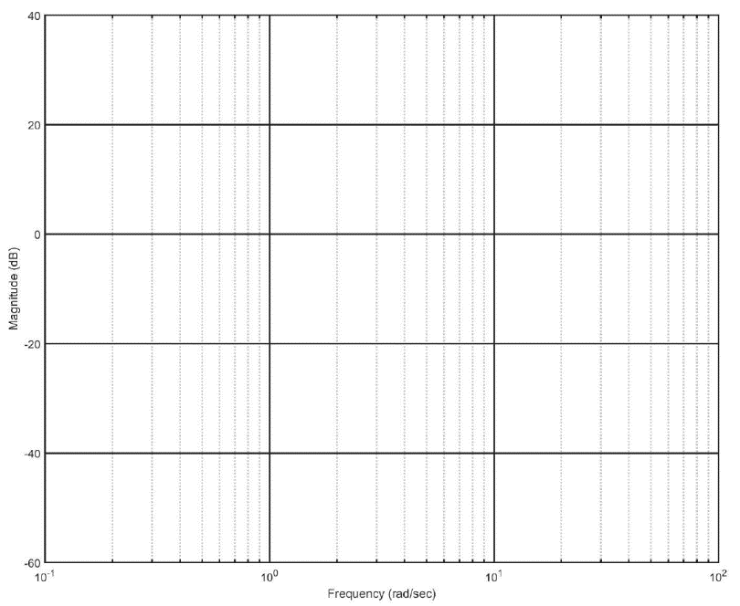
Determine points on Phase portion of Bode Plot
- Find decade below lowest break frequency: ____ rad/sec
Determine the phase at this frequency:
Constant: $_____°$
Integrator: $-90°*___= _____°$ total: $_____°$

- Find the decade below next break frequency: ____ rad/sec
Determine the slope to this frequency: ____ °/decade from s+1/1 total: ___°/decade
Determine phase at this frequency: #decades: log(___ rad/sec / ___ rad sec) = _____ decade
#degrees: ___°/decade * _____ decade = ____°
degrees: ___° + ___° = ___°

- Find the decade below next break frequency: ____ rad/sec
Determine the slope to this frequency: ____ °/decade from s+1/1
____ °/decade from second order total: ___°/decade
Determine phase at this frequency: #decades: log(___ rad/sec / ___ rad sec) = _____ decade
#degrees: ___°/decade * _____ decade = ____°
degrees: ___° + ___° = ___°

- Find the decade below next break frequency: ____ rad/sec
Determine the slope to this frequency: ____ °/decade from s+1/1
____ °/decade from second order
____ °/decade from s-50/-50 total: ___°/decade Determine phase at this frequency: #decades: log(___ rad/sec / ___ rad sec) = _____ decade
#degrees: ___°/decade * _____ decade = ____°
degrees: ___° + ___° = ___°

- Find the decade below next break frequency: ____ rad/sec
Determine the slope to this frequency: ____ °/decade from second order
____ °/decade from s-50/-50 total: ___°/decade Determine phase at this frequency: #decades: log(___ rad/sec / ___ rad sec) = _____ decade
#degrees: ___°/decade * _____ decade = ____°
degrees: ___° + ___° = ___°

- Find the decade below next break frequency: ____ rad/sec
Determine the slope to this frequency: ____ °/decade from s-50/-50 total: ___°/decade
Determine phase at this frequency: #decades: log(___ rad/sec / ___ rad sec) = _____ decade
#degrees: ___°/decade * _____ decade = ____°
degrees: ___° + ___° = ___°

